Object Oriented Programming (BNUxITM) Instructor: Huda Sarfraz
Assignment No. 6 (Lab) Max Marks: 10
Date: 15-Nov-2024 Time Allowed:

Create C++ classes and write a driver program to test them as per the following specification. All your work should be done in one .cpp file.

Create a banking application as per the following class diagram where a Bank object in your main reads account information from a file named accounts.txt, applies an annual profit as per the account’s profit rate and then writes the updated bank account information to a new file. Assume that the bank can have up to 100 savings accounts.

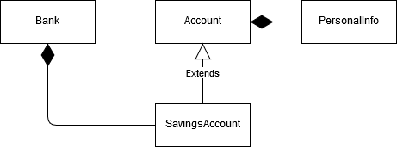

Input file sample

Firstname Lastname AccountNumber Amount ProfitRate

Huda Sarfraz 001-25672 550 0.03
Ayesha Sarfraz 001-72633 1000 0.02
Saman Ashraf 002-27839 2000 0.05

Output file corresponding to the sample input (test by varying number of accounts)

Firstname Lastname AccountNumer Amount(new) ProfitRate

Huda Sarfraz 001-25672 566.5 0.03
Ayesha Sarfraz 001-72633 1020 0.02
Saman Ashraf 002-27839 2100 0.05

ADT specification
class PersonalInfo {
public:
void setfname(string);
void setlname(string);
void print();
private:
string fname;
string lname;
};

class Account {
public:
double getAmount();
void setAmount(double);
void print();
void setAccountOwner(PersonalInfo);
void setAccountNumber(string);
private:
string account_number;
PersonalInfo account_owner;
double amount;
};

class SavingsAccount : public Account {
public:
void setInfo(string, string, string, double, float);
void applyProfit();
void print();
private:
float profit_rate;
};

class Bank {
public:
Bank(); // init number of accounts to zero
void getAccountsInfoFromFile(string);
void applyYearEndProfit();
void printAccounts();
private:
int num_of_accounts;
SavingsAccount accounts[100];
};

Driver program specification

- Create a bank object
- Read information into your bank object from the given file
- Calculate updated account amounts after annual profit calculation
- Print updated information to console

Submission guideline
- Submit your project
- Submit two sets of input and output files that you tested on

